

NAME: BISMA FATIMA
CLASS: CS A
ROLL NO: F24605036
COURSE: COMPUTER NETWORK
COURSE CODE: CS-271
LECTURER: SIR NAVEED YOUSAF

ASSIGNMENT 04

A Case Study on a Major Routing Failure: The Facebook/Meta Outage of October 2021
Incident Overview
The incident occurred on October 4, 2021, starting around 15:40 UTC and lasting approximately six to seven hours, with full restoration by around 22:50 UTC. Facebook (now Meta) and its subsidiaries—including Instagram, WhatsApp, Messenger, Oculus, and Mapillary—became completely unavailable worldwide. This affected billions of users across all regions, preventing access to social networking, messaging, and even third-party services relying on "Log in with Facebook." The outage also disrupted Meta's internal tools, blocking employee access to communications and systems.

Root Cause Analysis
The root cause was a faulty configuration change on Meta's backbone routers during routine maintenance. An unintended command disconnected all connections in the global backbone network, isolating Meta's data centers. This triggered a safety mechanism in their DNS servers: since they could no longer reach the data centers, the servers automatically withdrew their BGP route advertisements.
The primary protocol involved was Border Gateway Protocol (BGP), the inter-domain routing protocol that exchanges reachability information between autonomous systems (ASes) on the Internet. No internal protocols like OSPF were directly implicated in the external outage.

Role of the Network Layer
The failure originated at the network layer (Layer 3 of the OSI model), where routing decisions occur. The backbone disconnection prevented Meta's AS (ASN 32934) from advertising routes to its prefixes, including those hosting DNS servers. BGP withdrawals propagated rapidly across the Internet, removing Meta's networks from global routing tables.
This propagation happened because BGP relies on periodic announcements; when Meta stopped advertising its prefixes (e.g., 185.89.218.0/23 and 129.134.30.0/23), routers worldwide updated their tables to reflect the withdrawal. A key misconfiguration contributing factor was the dependency of DNS route advertisements on backbone health—intended as a failover safeguard but resulting in a complete external disconnect when the backbone failed entirely.

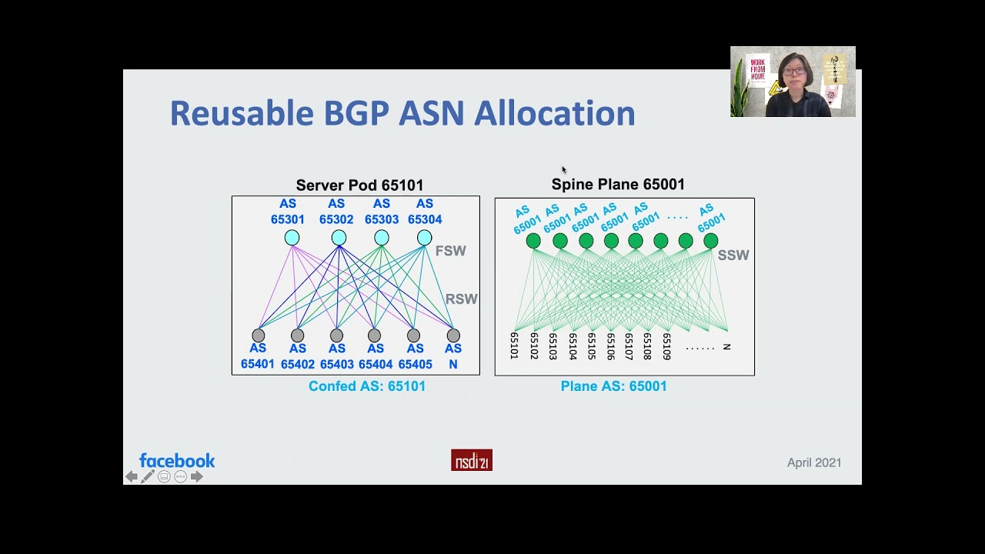
theverge.com
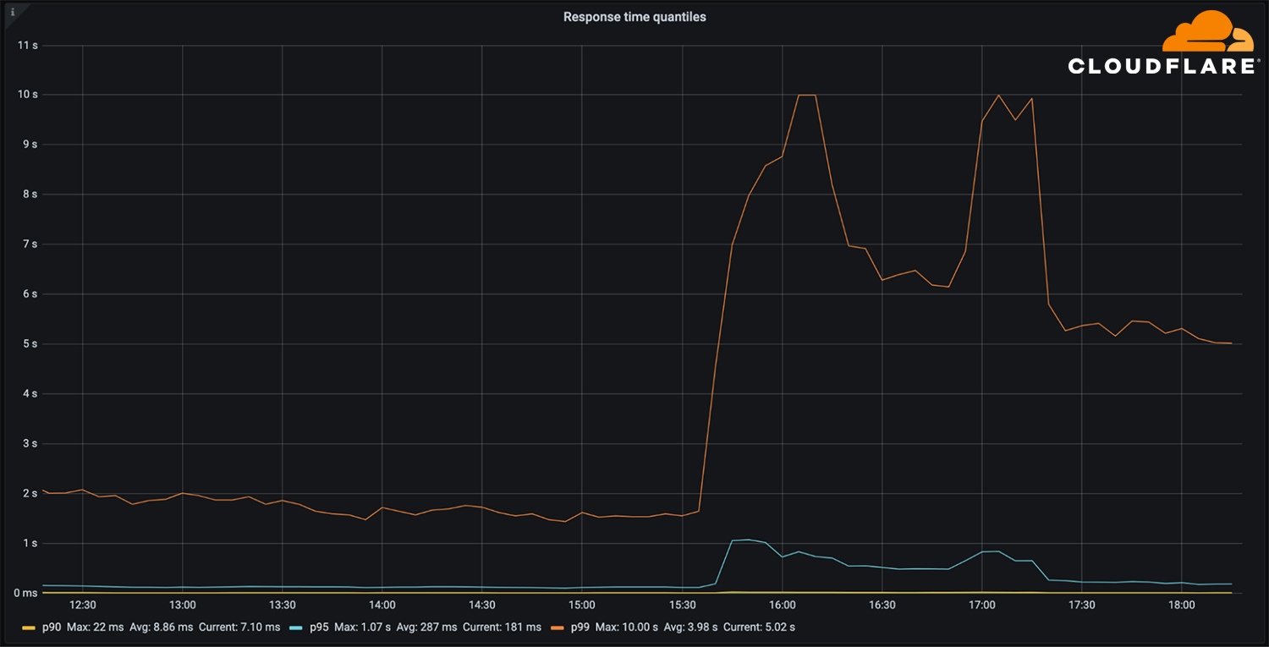
blog.cloudflare.com
(Above: Illustrative diagrams showing BGP route withdrawals during the outage and normal vs. disrupted routing paths.)

Technical Breakdown
In normal operation, Meta advertises BGP routes to its prefixes, allowing Internet routers to forward packets to its data centers and DNS servers. DNS resolves domains like facebook.com to IPs, and packets follow BGP-selected paths.
During the outage:
- A configuration command assessed backbone capacity but accidentally severed all backbone links.
- Data centers became isolated internally.
- DNS servers detected the loss and withdrew BGP advertisements for their prefixes.
- Global routers removed these routes from tables, making DNS unresolvable (SERVFAIL errors).
- Without DNS resolution, applications could not connect, even if some routes lingered temporarily.
Packet forwarding failed because routing tables lacked entries for Meta's IPs—packets were dropped or undeliverable. This cascaded to amplify load on other services (e.g., 30x DNS query spikes to alternatives like Cloudflare's 1.1.1.1).
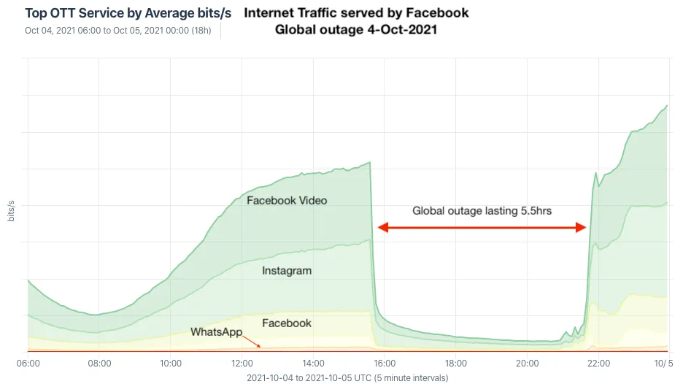
en.wikipedia.org
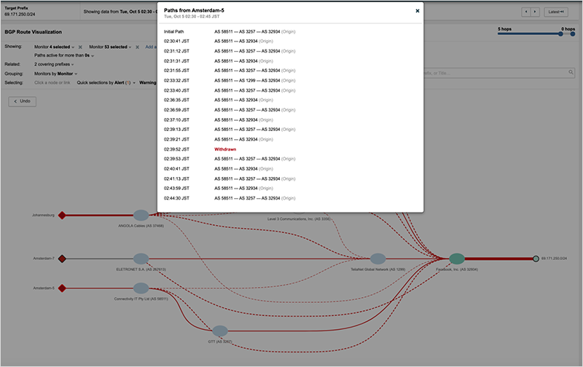
thousandeyes.com
(Above: Graphs depicting traffic drop-off and BGP update spikes during the incident.)

Response and Resolution
Meta identified the issue through monitoring but faced challenges: internal tools relied on the same infrastructure, hindering remote fixes. Engineers gained physical access to a data center (Santa Clara, California) to reset servers manually.
Resolution involved reversing the configuration change, allowing backbone reconnection. BGP announcements resumed around 21:00 UTC, with DNS recovering shortly after. Post-incident, Meta implemented changes like better audit controls for commands, separation of internal tool dependencies, and enhanced backbone resilience testing.

Lessons Learned
Key takeaways include the fragility of single points of failure in large-scale networks, the cascading risks of safety mechanisms (e.g., auto-withdrawals), and the need for out-of-band management tools independent of primary infrastructure. Network engineers should prioritize rigorous change management, including pre-deployment simulations and automated safeguards against broad-impact commands. Prevention involves adopting protocols like RPKI (Resource Public Key Infrastructure) for route validation and MANRS (Mutually Agreed Norms for Routing Security) for better filtering.

Your Analysis
Current Internet routing protocols like BGP are reasonably robust for scalability and decentralization but inherently vulnerable due to their trust-based design—no built-in authentication for announcements. Misconfigurations or hijacks propagate easily, as seen here and in past incidents (e.g., 2008 YouTube hijack). While not fragile in daily use, BGP lacks modern security, making large outages possible from human error.
Global Internet routing should not be more centralized, as that risks single points of failure and censorship. Instead, enhanced monitoring and voluntary standards (e.g., widespread RPKI adoption, prefix filtering) are preferable, preserving the decentralized nature while improving security through cooperation.

References
- Cloudflare Blog. (2021). "Understanding how Facebook disappeared from the Internet." https://blog.cloudflare.com/october-2021-facebook-outage/
- Engineering at Meta. (2021). "More details about the October 4 outage." https://engineering.fb.com/2021/10/05/networking-traffic/outage-details/
- Cloudflare Learning. "What is BGP?" https://www.cloudflare.com/learning/security/glossary/what-is-bgp/

